MASCHERPA Audric ROB 3 2022 / 2023

**POLY-SNAKE**

**Weekly report n°6 from 06/12/22 :**

I spent the first hours of this session helping my partner on the programming of the Poly-Snake movement. Indeed, the movement of the snake being at the heart of the project, it was imperative to finish the program at the latest after the December holidays.

Here is a Github link to the program produced :

<https://github.com/YOUSSNDR/PolySnake/blob/main/programmes/servomoteurs/programme%20fonctionnel/version%20fonctionnelle/version%20fonctionnelle.ino>

Next, we were able to carry out the first tests using 3D prints made during the last sessions.

Here is a Youtube link of the video of the first test :

<https://youtube.com/shorts/3seGkPpCPjw?feature=share>

It is important to note that the test was carried out with 3 modules in order to verify the program and its proper functioning. Thereafter we will test the program with more modules to gradually approach the final size of the PolySnake.

Figure 6.1

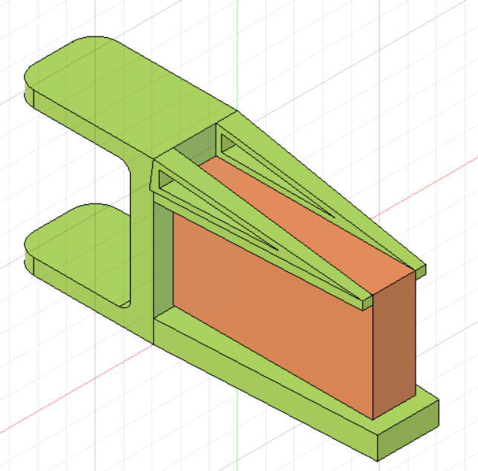Finally, while waiting for my partner to finish adjusting a few details on the program, I decided to move forward with the modeling of the snake's tail which will accommodate the robot's power supply in figure 6.1.

We can see in orange a representation of the battery that will be used for our project and in green the 3D modeling of the tail.

It is important to note that this is not the final version of the PolySnake tail and that a lot of things still need to be reviewed before we can print the part and add it to the body of the snake.